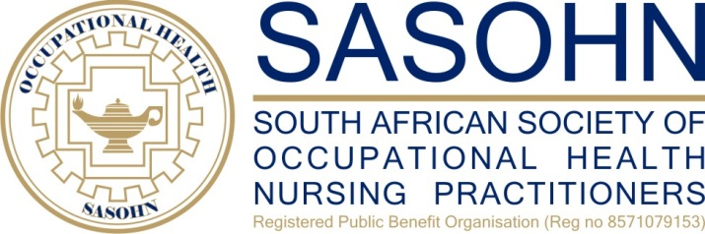

09th April 2020

Dear SASOHN Members

**Re – UPDATE COVID19 PANDEMIC**

**Day 14 of Lock down, and health care workers are seen as essential services throughout the world. Some of us are fighting issues of not having PPE and being exposed to the virus. Some are trying to make the best of the period of isolation and yet others are trying to survive cabin fever.**

* Who would have thought that the “Year of the Nurse” would be so busy yet rewarding that globally everyone is praising nurses and thanking us for being at the frontline of this pandemic. I too, would like to thank each and every one of you for all your efforts and working so hard to assist in this time of crisis.
* So many changes that have forced us to be creative, use technology and adapt to the 4th Industrial revolution. Never before had I seen online training, making use of Zoom and Teams that make training happen anywhere, any time. Remote learning.
* With everything still in a state of flux, not knowing whether the lock down will be extended, it still remains a challenge to have definite dates for the Academic days. However, NIOH will be assisting in trying to get CEU’s for the nurses. Should you have missed some of their training, kindly log onto their website to do some catch up sessions. Also make use on their toll free number for any advice that you would need. Hotline specifically for COVID 19 Occupational Health Queries. This is manned by NIOH staff members - 0800 21 21 75
* At this time, I would like to emphasise that each of you have dear and loved ones. Please use your PPE accordingly and ensure that you do the necessary risk assessments. Your loved ones would also like you to be healthy, and know that you would not expose them unnecessarily. So let’s do the right thing and work within our scope of Practice.
* We have made some progress with our Dispensing Licence issues, so look out for that communication which should be any day now.
* Sadly, the website still continues to give us problems. For now, we still remain focused on updating the database. Please be patient with us during this time.
* Most of us continue to make use of social media, please be careful on what you post.

**I am aware that there is an information overload on COVID 19. This is so we are always updated and on track. But it is also necessary to focus on the Health and Wellbeing of the Occupational Health Nurse Practitioner. Please look out for these articles and advice. Don’t forget to take care of Yourselves.**

***I wish that each and every one of you stay safe, and have a Blessed Easter.***

Kind regards

Denise Minnie

SASOHN President